DBMS Assignment – 4 Part- B

Name- Ayush Mondal

Enrolment No. - 2011200001017

Department- CSE

Group – A

46) Display s_name with left side padding by at least 3 *.

Query

select lpad(sname , length(sname)+3, '*') as name from sailor;

Output

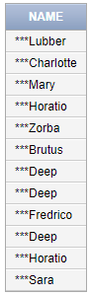

47) Display length of each name.

Query

select length(sname) as length from sailor;

Output

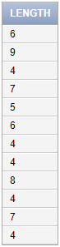

48) Display all sailors names in uppercase.

Query

select upper(sname) as name from sailor;

Output

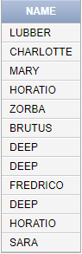

49) Display all sailors’ names in lower case.

Query

select lower(sname) as name from sailor;

Output

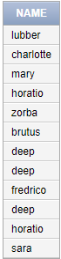

50) Display all sailors names in sentence case.

Query

select initcap(lower(sname)) as name from sailor;

Output

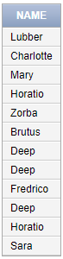

51) Display 4th to 7th letter of sailors name.

Query

select substr(sname, 4, 4) as name from sailor;

Output



52) Display 4th and 7th letter of sailors name.

Query

select substr(sname, 4, 1) || substr(sname, 7,1) as letters from sailor;

Output

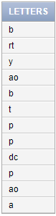

53) Concat s_id, s_name.

Query

select concat(sid, sname) as conacat from sailor;

Output

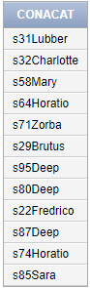

54) Display square root of rating.

Query

select sqrt(rating) as sqrt from sailor;

Output

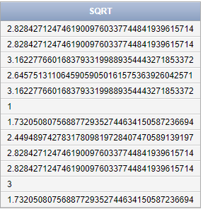

55) Display floor values of all ages.

Query

select floor(age) as floor from sailor;

Output

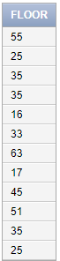

56) Display ceiling values of all ages.

Query

Select ceil(age) as ceil from sailor;

Output



57) Select all s_name with 1st 2 letters off.

Query

select substr(sname, 3, length(sname)-2) as name from sailor;

Output



58) List months between today and reservation date.

Query

select r_day, months_between(sysdate, r_day) as months from sailor_boat;

Output

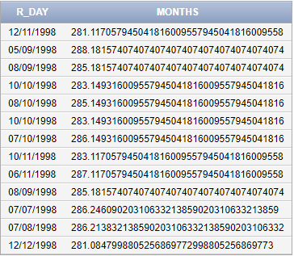

59) Select day between today and reservation date.

Query

select r_day, sysdate - r_day as days from sailor_boat;

Output

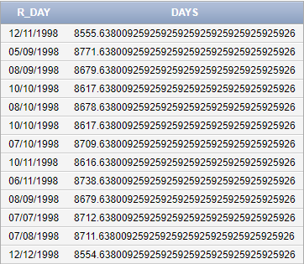

60) Shift all reservation day by 2 months.

Query

select r_day, add_months(r_day, 2) as months from sailor_boat;

Output

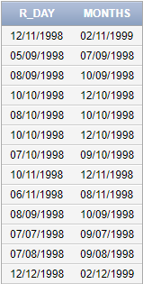

61) Shift all reservation day earlier by 3 months.

Query

select r_day, add_months(r_day, -3) as months from sailor_boat;

Output

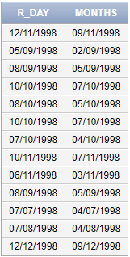

62) Suppose after sailing they enjoy their next Monday as holiday. Find that day.

Query

select r_day, next_day(r_day, 'Monday') as holiday from sailor_boat;

Output

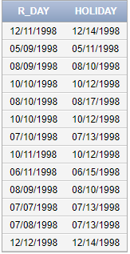

63) Display 3 * before and after each s_name.

Query

select rpad(lpad(sname , length(sname)+3, '*'), length(sname)+6, '*') as name from sailor;

Output

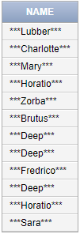

64) Find the date when sailing ends.

Query

select r_day, last_day(r_day) as ends from sailor_boat;

Output

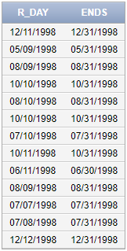

65) Display all reservation day.

Query

select r_day, to_char(r_day, 'DAY') as days from sailor_boat;

Output

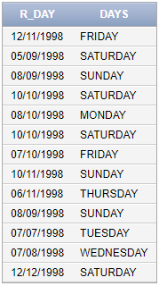

66) Find the position of ‘Kumar’ in the sailors name.

Query

select count(*) as position from sailor where sid <= (select sid from sailor where surname = 'Kumar') order by sname||mname||surname;

Output



67) Display all sailors name order by its length.

Query

select sname || ' ' || mname || ' ' || surname as name from sailor order by length(sname||mname||surname);

Output

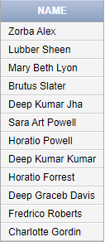

68) Display sid,sname and availability of middle name which print as ‘available’ or ‘not available’.

Query

select sid, sname, 'available' as availability from sailor where mname is not null union select sid, sname, 'unavailable' as availability from sailor where mname is null;

Output

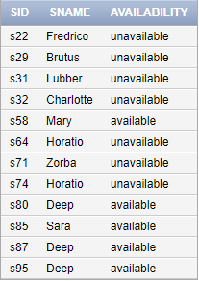

69) Display all reservation day like ‘22nd March twenty ten’ and 12/09/1998.

Query

select to_char(r_day, 'DD/MM/YYYY') as r_day1, to_char(r_day, 'ddth Month year') as r_day2 from sailor_boat;

Output

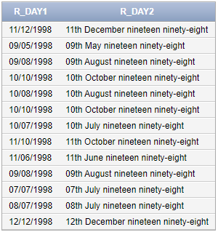

70) Find the day of weekdays of reservation date.

Query

select r_day, to_char(r_day, 'DAY') as weekdays from sailor_boat where to_char(r_day, 'D') not in (1, 7);

Output

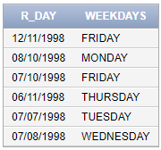

71) Find the number of day of weekdays of reservation date.

Query

select r_day, to_char(r_day, 'D') as weekdays from sailor_boat where to_char(r_day, 'D') not in (1, 7);

Output

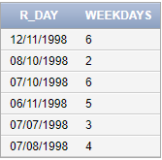

72) Find the number of days passed upto reservation date of that year.

Query

select r_day, to_char(r_day, 'DDD')-1 as days from sailor_boat;

Output

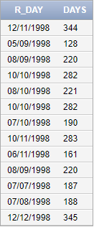

73) Display the number of weeks of the year for reservation day.

Query

select r_day, to_char(r_day, 'WW') as weeks from sailor_boat;

Output

